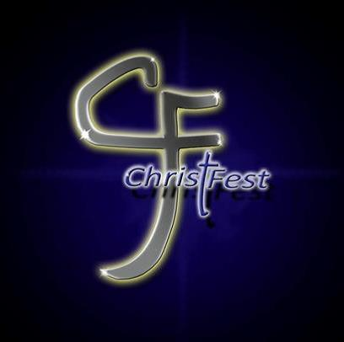
Christ Fest Music Ministry Application

Name of Primary Contact for Music Group: ____________________________
Primary Contact Phone Number: _____________________________________
Primary Contact Email Address: ______________________________________
Home Church of Music Group: _______________________________________
Type of Music Group (i.e. Dance Team, Praise Team, Choir, Christian Rock Band):
______________________________________________________________________
Brief Description of who you are as a music group, and the main focus of your ministry as a music group:
_________________________________________________________________________________________________________________________________________________________________________________________________________
*Groups that were slated to perform last year will be given first consideration because the event was rained out. All other slots will be filled on a first come, first serve basis because there are a limited number of performance slots to fill.
Christ Fest this year will take place at the Delaware County Fairgrounds, so weather will not be an issue. There will be a youth night on Friday, September 15th from 6PM – 10PM and the main event will be on Saturday, September 16th from 12PM – 10PM.
The Primary Contact provided on this sheet will be contacted by a Christ Fest Committee Representative when the application is received. Failure to answer or return communication may result in the disqualification of your group’s participation in Christ Fest. Applications open on Monday, May 8th, and close on Monday, July 3rd. Applications can be mailed to Tabernacle of Praise, Attn: Amy Brooks, 2200 E. Fuson Rd., Muncie, IN 47302, or scanned and emailed to altbrooks@gmail.com.

